Pupil premium strategy statement

This statement details our school’s use of pupil premium (and recovery premium for the 2023 to 2024 academic year) funding to help improve the attainment of our disadvantaged pupils.

It outlines our pupil premium strategy, how we intend to spend the funding in this academic year and the effect that last year’s spending of pupil premium had within our school.

School overview
Detail | Data
School name | Malcolm Sargent Primary School
Number of pupils in school | 641
Proportion (%) of disadvantaged pupil premium eligible pupils  Key  DPP – Deprivation Pupil Premium  AFC – Adopted from Care  LAP – Looked After Pupil | 81 pupils (13%)  - 77 DPP  - 4 AFC
Academic year/years that our current pupil premium strategy plan covers (3-year plans are recommended) | 2021- 2024
Date this statement was published | September 2023
Date on which it will be reviewed | September 2024
Statement authorised by | T. J. Revell
Pupil premium lead | H. Ward
Governor / Trustee lead | TBC
Funding overview
Detail | Amount
Pupil premium funding allocation this academic year (2023/24) | £144,620
Recovery premium funding allocation this academic year (2022/23) | None
Pupil premium funding carried forward from previous years (enter £0 if not applicable) | £0

Part A: Pupil premium strategy plan

Statement of intent
- What are your ultimate objectives for your disadvantaged pupils?
- Ultimately, our disadvantaged pupils will be academically successful- which means that they make the most of their potential and make even more progress than the average of similar non-disadvantaged pupils nationally, in order to “close the gap” in academic achievement. These pupils will be happy, contributing members of society who are ready to move on to the next stage of school & ultimately well prepared for the wider world beyond.

- How does your current pupil premium strategy plan work towards achieving those objectives?
- We purchase evidenced based learning programmes for English & Maths that are proven to demonstrate high quality outcomes for pupils & even better progress for disadvantaged pupils. This includes programmes for the early acquisition of key reading skills in the early years. Teachers’ delivery is well supported including through effective training.
- Then, we systematically identifying & then tackle areas of pupil’s under achievement so that gaps in learning are addressed in order for pupils to rapidly make progress with small group or individual intervention.
- Pupils’ “readiness to learn” will be improved with the assistance of our pastoral support team- including a focus on ensuring excellent attendance.

- What are the key principles of your strategy plan?
- Teaching: By first ensuring high quality class teaching which follows a well-designed effective programme of sequential learning focused on key academic Maths & English skills.
- Targeted Academic support: We use the pupil premium to buy extra help. We use question level analysis of pupil assessments in order to focus intervention work most effectively on those concepts in Reading, Writing or Maths that a child does not know well enough yet. Then we provide intervention sessions in small groups 1:1 or 1:3 for a limited time period outside of the core school day, so that no further learning is lost.
- Wider strategies: Our pupil premium budget helps to fund the three members of our pastoral team who are tasked with improving pupils’ “readiness to learn”. In addition to improving pupil attendance, they also promote pupil engagement, wellbeing, mentoring & removal of barriers to learning.

Challenges

This details the key challenges to achievement that we have identified among our disadvantaged pupils.
Challenge number | Detail of challenge
1 | Progress in Reading to ‘close the gap’ with non-disadvantaged peers.
2 | Progress in Writing to ‘close the gap’ with non-disadvantaged peers.
3 | Progress in Maths to ‘close the gap’ with non-disadvantaged peers.
4 | Readiness to learn, including emotional wellbeing-.  - ‘Regulate before educate’ – importance of addressing pupils’ social and emotional difficulties alongside academic needs. A high proportion of the pupils supported each day by the pastoral team are disadvantaged.  - Engagement of “hard-to-reach” families - mitigated by the designation of SLT leader to drive & direct targeted pastoral support & assist where necessary  - High percentage of vulnerable pupils within persistent absenteeism  - Attendance for disadvantaged pupils is weaker than their non-disadvantaged peers.

Disadvantaged pupil progress scores for last academic year based on 16 pupils
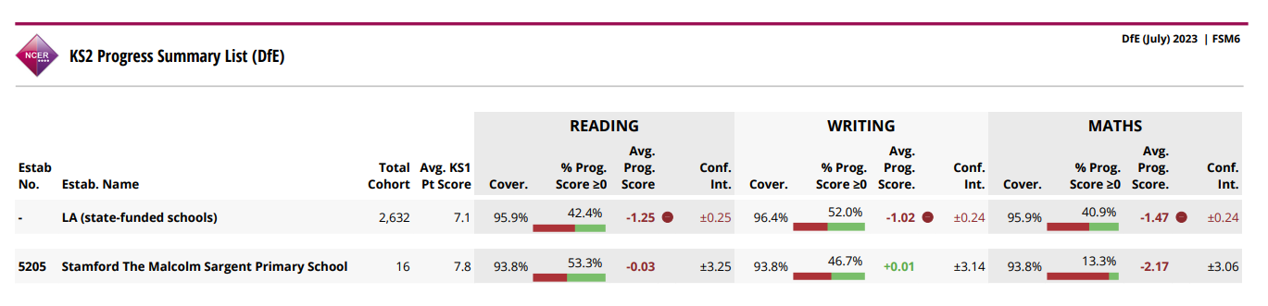

Disadvantaged pupil performance overview for last academic year
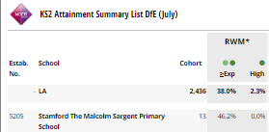

Intended outcomes
This explains the outcomes we are aiming for by the end of our current strategy plan, and how we will measure whether they have been achieved.

Intended outcome | Success criteria
Progress in Reading | Exceed national average progress scores in KS2 Reading (0)
Progress in Writing | Exceed national average progress scores in KS2 Writing (0)
Progress in Mathematics | Exceed national average progress scores in KS2 Maths (0)
Phonics achievement | Exceed national average expected standard in PSC of 75%
Attendance | Improve attendance of dis. pupils to exceed 2022/23 National average of 93.8%

Activity in this academic year
This details how we intend to spend our pupil premium (and recovery premium funding) this academic year to address the challenges listed above.

Teaching (for example, CPD, recruitment and retention)
Budgeted cost: £15,700
Item | Budget
RWI | £8,000  (To include subscriptions, training and resources)
Power Maths | £6,200  (To include subscriptions, training and resources)
‘The Write Stuff’ and ‘The Spelling Book’ | £1,500 – The Write Stuff  (To include subscriptions, training and resources)
Total | £15,700

Activity | Evidence that supports this approach | Challenge number(s) addressed
Ensure all relevant staff have received training to deliver Literacy effectively, namely:  Read Write Inc. – a whole-school approach to teaching literacy for 4 to 9-year olds that creates fluent readers, confident speakers and willing writers. It integrates phonics with comprehension, writing, grammar, spelling and handwriting, using engaging partner work and drama. | DfE evaluated & approved schemes. EEF Comprehension +6 months progress.  EEF Phonics +4 months progress | 1
Work with the Maths hub & purchase textbooks to embed Teaching for Mastery across all year groups, using the ‘Power Maths’ teaching scheme. | DfE approved schemes supported by the regional Maths hub.  Mastery learning +5 months EEF evaluation. | 3
Improving the quality of classroom teaching of pupils’ independent writing recovery from the impact of the pandemic: “If they can’t do it by themselves, then they can’t do it…yet.”  Using ‘The Write Stuff’ and ‘The Spelling Book’ approach | Mastery learning +5 months EEF evaluation. | 2

Targeted academic support (for example, tutoring, one-to-one support structured interventions)
Budgeted cost: £48,567.22
Item | Budget
Accelerated Reader | £3341.22
SHINE question level analysis tool intervention | £1000
Tuition - small Group Interventions | £44,226
Total | £48,567.22

Activity | Evidence that supports this approach | Challenge number(s) addressed
Buy and embed use of Accelerated Reader across year groups 3 to 6, to support diagnostic tracking & improve reading for pleasure.  Accelerated Reader (AR) is a reading management and monitoring programme that aims to foster independent reading. The internet-based software assesses reading age, and suggests books that match pupils’ needs and interests. Pupils take computerised quizzes on the books and earn AR points as they progress. | +5 months progress EEF | 1
The Nuffield Early Language Intervention (NELI) is designed to improve listening, narrative and vocabulary skills. Three to five weekly sessions are delivered to small groups of children with relatively poor spoken language skills. The 30-week programme starts in the final term of nursery and continues in reception year. The 20-week programme is delivered in reception only. | DfE researched & approved programme.  +4 months progress EEF trial | 1,2
Establish 1:1 and small group reading/maths interventions for disadvantaged pupils falling behind age-related expectations. | Feedback = +8 months progress EEF | 1, 2, 3

Wider strategies (for example, related to attendance, behaviour, wellbeing)
Budgeted cost: £80,352.78 [Contribution towards total pastoral support costing the following]
Item | Budget
Pastoral Support staff | £72,614
Hardship Fund | £7,738.78  (To include emergency support, PGL support and wider opportunities workshops)
Total | £80,352.78

Activity | Evidence that supports this approach | Challenge number(s) addressed
We use some of our Pupil Premium funding to contribute towards the cost of our Pastoral Support Team. They aim to:-  - ‘Regulate before educate’ – importance of addressing pupils’ social and emotional difficulties alongside academic needs  - Engagement of “hard-to-reach” families - mitigated by the designation of SLT leader to drive & direct targeted pastoral support & assist where necessary  The team focus on improving attendance, readiness to learn, including support for learning off-site using our learning platform to minimise disruption to learning. | The core role of the pastoral team is taken from DfE Effective use of Pupil Premium Guidance. It is to:  - increase pupils’ confidence and resilience  - encourage pupils to be more aspirational  - benefit non-eligible pupils too  EEF Parental engagement+3 months  Social & Emotional learning +4 months | 4
Roots to Food Inspire+ session, engaging selected parents and pupils to develop their understanding of nutrition and food preparation | EEF Parental engagement+3 months | 4
Paralympic workshop Inspire + session to encourage pupils to develop sporting resilience and overcome obstacles. | EEF Social & Emotional learning +4 months | 4
Art Pop Up Family Event. A 2 hour session after school for selected families to attend an art session with a professional artist to develop their engagement and understanding of art techniques  For Example:  October 2022 session – 5 families supported including 18 children  December 2022 session – 7 families supported including 22 children  January 2023 session – 6 families supported including 22 children  Some attendees of the Art events have since attended Art Pop Up community events in Stamford. | EEF Parental engagement+3 months | 4
Christmas Present Appeal – Appeal to the local community, including Morrison’s Stamford, Round Table and local businesses.

For example in 2022/23:
All PP parents invited to the free event held on 15th December. Invite forwarded out to all families for any in hardship, not in receipt of PP.

17 families supported with the event (2 of which were from Acorn Childcare Centre) with at least 7 Christmas presents for each child as well as unlimited books and hats/gloves, a selection box per child and mince pies for the family. Some families had the presents wrapped by staff volunteers and delivered to family homes the following day.

Excess donations passed onto Bluecoat School, St Augustine’s School and Corby Glen School for their PP families in need.
Total cost for pupil premium strategy: £144,620

Part B: Review of outcomes in the previous academic year

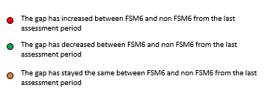
Pupil premium strategy outcomes
This details the impact of our pupil premium work for pupils in 2022/23 academic year.

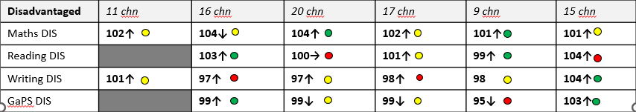
PP assessment data for Summer 2023
Narrowing the gap:
- Y1 in Summer 2023 – DPP pupils have ‘kept up’ with their non-DPP peers in Maths and Reading.
- Y2 in Summer 2023 – DPP pupils have made accelerated progress in Reading and GaPS and ‘kept up’ in Maths. Writing is a focus in Y3 PP in 2023/24.
- Y3 in Summer 2023 – DPP pupils have made accelerated progress in Maths and ‘kept up’ in Writing and GaPS. Reading is a focus for Y4 PP in 2023/24.
- Y4 in Summer 2023 – DPP pupils have ‘kept up’ in Maths, Reading and GaPS. Writing is a focus for Y5 PP in 2023/24.
- Y5 in Summer 2023 – DPP pupils have made accelerated progress in Maths and Reading and have ‘kept up’ in Writing. GaPS is a focus for Y6 PP in 2023/24.
- Y6 in Summer 2023 – DPP pupils have made accelerated progress in Writing and GaPS and ‘kept up’ in Maths.

What next?
Our new writing approach has a focus on ensuring that children with who have ‘vocabulary poverty’ are scaffolded through modelling and exposed to rich and varied language. We are continuing to keep Writing as a priority in our period of covid impact.

3 classes are trialling a new Reading scheme which will continue the same structure as our current approach with even more emphasis on modelling and fluency. If successful at trial, this will be launched in Autumn 2 2023 to the whole school.

Our subject leaders will continue to work with particular year groups and teachers to ensure the PP children have the support and resources required to continue narrowing the gap.
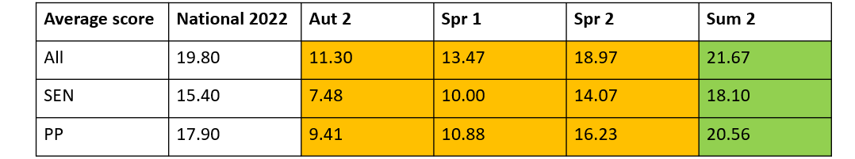
MTC check 2023

MSPS PP children achieved higher than ‘National all’. We will continue to support PP children through interventions to prepare for the MTC as well as access to devices where required for home practise (for example TT Rockstars).
EYFS Summer 2023 (2 pupils)
The EYFS lead will continue to identify what further support is required through Interventions and additional resources within the classroom.
PP GLD – 0/2 = 0%
PP Prime – 1/2 children = 50%
PP Reading 0/2 children = 0%
PP Maths 1/2 children = 50%
PP Writing 0/2 children = 0%
Aim | Outcome
DIS. pupils have been disproportionately affected by COVID-19 lockdowns- and overall, improvement in narrowing their achievement gap has stalled. However, there has been notable success of the Reading strategy, interventions, phonics & attendance work. This is a great basis for continued educational recovery for this group.
Reading Progress | Strategy is on track towards aim: Both RWI Comprehension, NELI and Accelerated reader have had significantly positive impact in the school, despite the effects of COVID-19 disruptions. The introduction of Comprehension Plus in Y2-Y6 in 2022/23 has supported the immerse vocabulary focus for reading and provide a clear structure for teaching retrieval, inference and evaluation. A trial is taking place in Autumn 1 2023 to introduce the Jane Considine Reading Comprehension to provide an even greater quantity of teacher modelling and fluency in reading lessons. We will carefully monitor the trial and, if successful, we will roll out ‘whole school’ in Autumn 2.
Maths Progress | Overall the strategy is on track towards aim: we will keep the termly assessment data under close review to ensure fidelity of the approach. Immediate intervention will be put in place if needed.  Mastery will continue to be embedded across the school and focussed small group/individual interventions to address specific knowledge gaps which have been exacerbated by the pandemic that are inhibiting the rate of further maths progression for some children.  Ensure consistency in delivery mastery approach, use of Power Maths scheme. Continue to focus on maths progress in SHINE interventions next year and implement targeted Maths support for individuals as required.
Writing Progress | Strategy is on track towards aim: There has been a very rapid improvement in writing achievement. There will be close monitoring to ensure this is sustained and further embedded across this academic year. This area of pupil achievement has, like most other schools, suffered most during the pandemic disruption with pupils remote independent writing whilst at home not as successful in “keeping up” with age related expectations as other areas of their curriculum.  As a result, we have introduced a new scheme, ‘The Write Stuff’ which provides a vocabulary rich, clearly modelled approach to overcome ‘vocabulary poverty’ and increase stamina of independent writing. Summer 2023 progress for PP children showed an almost flat progress score of -0.03 vs a national progress score of -1.25. Summer 2023 writing was moderated externally.
Phonics | Strategy is on track towards aim: 92% of PP children passed their Phonics Screening Check in Year 1 compared to 90% non-PP at MSPS and 75% nationally.  RWI phonics has had a significantly positive impact in the school, despite the effects of COVID-19 disruptions. We will continue to carefully monitor both delivery of the programmes consistently & the progress of PP children- using focussed interventions where necessary.
To ensure all barriers to their learning are removed or reduced to help them reach their full potential. Some of these barriers might be social, personal and emotional, or how regularly they attend school. | On track towards aim: Excellent work done throughout lockdown periods to engage our disadvantaged pupils, providing technology and support throughout, inviting dis-engagers into school as needed. Rising Stars ‘Shine’ targeted interventions have supported these pupils with tuition sessions before and after school along with the after school school-led tutoring programmes run by our own teachers and HLTAs.  Attendance for this group of dis pupils is 94.6% (National average 93.8%)  Although now close to the attendance figures of all pupils at the school, our disadvantaged pupils still have poorer attendance than non-disadvantaged pupil: attendance of Dis. Pupils 94.6% vs attendance rate of all pupils 96.7%.  Continued & targeted focus of pastoral team to engage & improve attendance - use of learning platform to ensure educational opportunity is not lost by non-attendance.  Use of members of staff to support after school provision of Choir, Drama, Green Team and Sport. Target to have 25% of participants who are PP.

Externally provided programmes
Please include the names of any non-DfE programmes that you purchased in the previous academic year. This will help the Department for Education identify which ones are popular in England
Programme | Provider
Power Maths | Pearson
Read Write Inc. Comprehension, Phonics, Spelling | Ruth Miskin Phonics Training
Accelerated Reader | Renaissance learning
The Write Stuff and The Spelling Book | Jane Considine Training
SHINE | Rising Stars

Service pupil premium funding
Proportion of Service children | 2.2% (14 pupils):  [Nb: additionally +3 pupils of US Services]
(Service Child premium allocation) | 14 Service Pupil Premium x £335= £4690
Measure | Details
How did you spend your service pupil premium allocation last academic year?  Contributing to the cost of employing our Pastoral support team in order to provide social, emotional support & mentoring for pupils and support for parents.  We have designated one of our pastoral support officers as our Services support leader. However, all of our pastoral team- led by the Vice Principal- give extra support to service pupils whilst at our school. They also provide pastoral activities, which recognise & celebrate the work of the armed forces, enhancing the connectedness & network of these pupils & their families. | Pastoral support is given to pupils and their families during challenging times and to help mitigate the negative impact on service children of family mobility or parental deployment.
What was the impact of that spending on service pupil premium eligible pupils? | Successful support of 14 pupils (13 families) before, during and after overseas deployments. 2 new service pupils were helped integrate into our school following redeployments to the area. This entailed bespoke support including use of the “Little Troopers”, “Separation Pack”, SAFA support through Wittering RAF Base coordinator- & working with children during their parents deployments elsewhere including for example separation diaries, cross-off charts, letter writing & other “keeping in touch” activities.  Academic achievement of these pupils is high- exceeding the average of “all pupils” nationally. Attendance similarly is extremely high & behaviour excellent- pastoral team report happy well-motivated pupils.  We also support the following activities for all of our service pupils:  Armed Forces Day, Wittering “Fly the glider” challenge, Remembrance day poppy appeal, “Reading Force” service magazine’s book reading challenge.

