HOLIDAY CLUB BOOKING FORM
December 2024

Acorn Childcare Centre is pleased to be running its Christmas holiday club on Friday 20th December 2024, Monday 23rd December 2024, Thursday 2nd January 2025 and Friday 3rd January 2025.
Please see below the terms and conditions of booking:
- Bookings are to be made by using the form below. Please tick the day and session required and return via email to enquiries@acornchildcarecentre.co.uk
- The two session times will be 9am – 3pm or 7.30am – 6pm. You will be able to drop and collect children at any time during the longer day session, but you will be charged for the full day.
- 48 hours’ notice is required when cancelling sessions (weekends are not included in the 48 hours).
- All meals/snacks are provided except for lunch – please bring a healthy packed lunch each day. Drinking water will be provided at all times of the day therefore, no other drinks will be needed.
- All children must hold a current admission form with us and a deposit before attending. Admission forms can be requested at the Acorn office or via email.
- The 9am – 3pm sessions will be run to this exact start and end time. If you require extra time around this session, please book the longer day to accommodate your childcare needs.
- Sessions will be charged as follows: 9am – 3pm £28.00 and 7.30am – 6pm £44.00.
Any primary-aged child is welcome to attend our holiday club, even if they do not attend Malcolm Sargent Primary School, providing they are registered with Acorn before attending.
The below timetable is in addition to all our usual activities including pool table, table tennis, air hockey, Lego, small world play, arts and crafts, and football, cricket, basketball, giant games, and lots more!
All inside activities are subject to change depending on weather conditions.

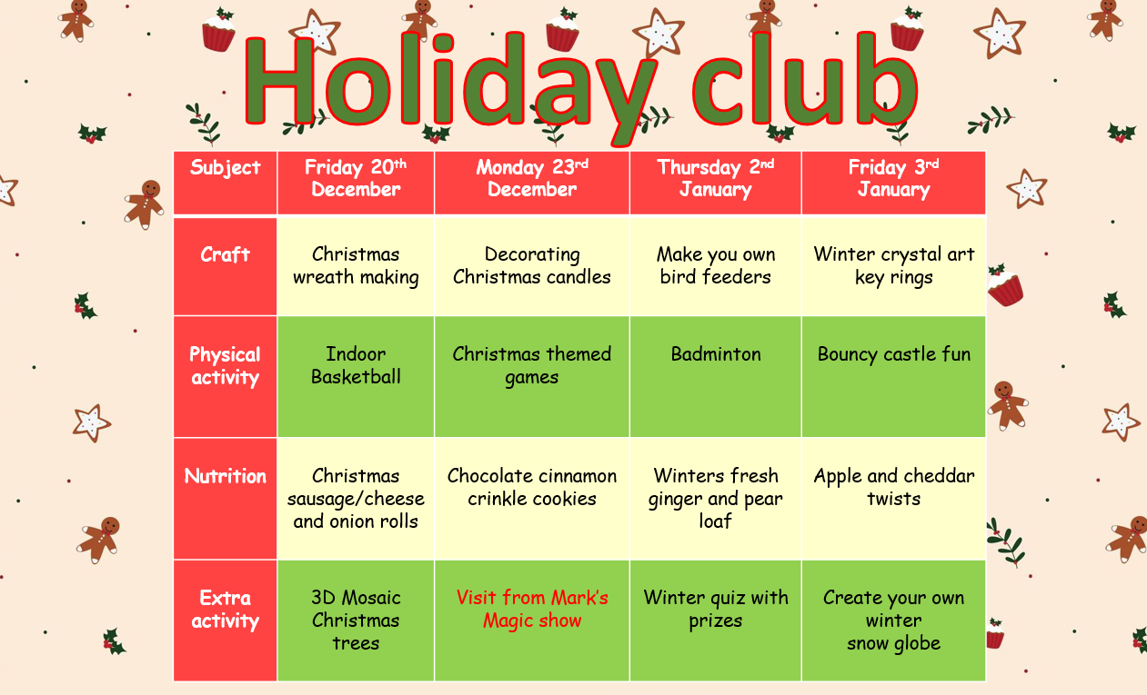

Please tick the day and session you require and return to enquiries@acornchildcarecentre.co.uk or drop into the Acorn reception.

Child/Children’s name:
Parent name:
Child/Children’s year group:

Day | Session 9am-3pm | Session 7:30am -6pm
Friday 20th December

Monday 23rd December

Thursday 2nd January

Friday 3rd January

