Understanding the World | Development Matters | Skills in EYFS | How this achieved in EYFS | By the end of EYFS the children will know…
Understanding the World | Reception:  - Draw information from a simple map.  - Recognise some similarities and differences between life in this country and life in other countries.  - Explore the natural world around them.  - Recognise some environments that are different to the one in which they live. | Autumn 1  Become familiar with immediate surroundings (school) and talk about its features  - I know where I live.  - I know some of the features of my immediate environment.  - I know the name of my school  Autumn 2  Begin to understand the effect of changing seasons on the natural world around them. (Autumn)  Describe what they see, hear and feel whilst outside.  - I know the names of the four seasons.  - I know the main features of the weather in each of the seasons.  - I know what harvest is.  - I know some of the festivals that are celebrated around the world.  Spring 1  Explore and care for natural world around them (birds in winter).  Begin to understand the effect of changing seasons on the natural world around them (winter) and make comparisons to previously experienced seasons.  Explore changing states of matter - freezing and melting.  Make observations about animals and environments, discuss similarities and differences.  Spring 2  Describe what they see, hear and feel whilst outside.  Recognise that some environments are different to the one in which they live.  Explore and ask questions about the world around them.  - I know some of the people who work in my community and what they do.  - I can draw information from a simple map.  - I know the names of the four seasons.  - I know the main features of the weather in each of the seasons.  - I can say some of the things I pass on my way to school.  - I know that London is the capital of England.  Summer 1  Make observations about animals and plants discussing similarities and differences.  Understand processes and changes in the natural world, including the seasons and life cycles, and make comparisons to previously taught (human life cycle).  - I know some of the animals and plants that live and grow around me.  Summer 2  Draw pictures and make observations about animals and plants, discussing similarities and differences (focusing on sea creatures in comparison to land creatures)  Recognise that some environments are different to the one in witch they live and make comparison between them. | Autumn 1  All about me  - Look at where we live, describe features we see on the way to school.  - Explore the school. What happens in each room?  - Find about schools around the World.  - Explore the school grounds, look at features of our school environment.  - Meet some of the people who help us around school and how they help our school community.  - Look at homes from around the world and compare them to our own.  - Introduce maps through Mr Wiggle and Mr Waggle.  Texts  On Every House on Every Street – Jess Hitchman  Autumn 2  Sparkly Celebrations  - Learn about Diwali and look at India on the globe.  - Explore seasonal change in Autumn and Winter.  - Autumn walk  - Exploring Autumn leaves – Outside transient art, parachute games, brushing up.  Text  Leaf Man- Lois Ehlert  Spring 1:  My Night Time World  - Observe seasonal weather changes and longer nights in the Winter compared to the Summer.  - Explore schools’ grounds observing seasonal changes in the winter.  - Mark making in frost.  - Explore compare/contrast our environment with polar regions.  - Ice exploration – freezing, melting and exploring changing states of matter.  Texts  A Winter Sleep – Hibernation Story Sean Taylor  All Through the Night – People who Work While we Sleep  Spring 2  On Our Doorstep  - Draw my route to school.  - Look at maps of Stamford and identify features on the map i.e. Field, outdoor classroom. (paper, Digi map and Google Earth).  - Make a map of the school grounds.  - Look at and discuss and variety of maps – theme park, local, forest, world, road map  - Go on a local walk to look at nearby streets and houses  - Bus trip around Stamford  - Introduce London as the capital of England.  - Observe, question and draw spring plants/spring growth (daffodils, blossom)  - Explore natural spring resources in Tuff Tray, asking questions and making/drawing observations.  Text  The Queens Hat – Steve Anthony  Martha Maps it Out - Leigh Hodgkinson  The Three Little Pigs (traditional)  My Granny went to Market – Stella Blackstone  Summer 1  Down in the Garden  - Exploring schools’ grounds and observing seasonal changes in the summer.  - Explore, observe and identify UK minibeasts.  (Life cycles getting warmer, food for them to eat)  - Butterfly Kit – Look at Life Cycle  - Hatching chicks – video  - Frogspawn  - Growing Sunflowers, courgettes, pumpkins to harvest next year.  Text  The Very Hungry Caterpillar – Eric Carl  Summer 2  We are Story Tellers  - Walk into town to the library.  - Name features around the UK (farm, beach, mountains, woodland etc). Link to holidays.  - Animal fact books – watch Blue Planet  - Exploring Y1 playground and classroom  Text  Billy’s Bucket – Kez Gray and Gary Parsons  The Lighthouse Keepers Lunch – Davis Armitage  Tiddler – Julia Donaldson  Snail and the Whale –  Commotion in the Ocean – Giles Andreae | Exceptional Explorer – I can talk about the world around me and changes in nature.  ELG People, Culture and Communities  - Describe their immediate environment using knowledge from observations, discussions, stories, non-fiction texts and maps.  - Explain some similarities and differences between life in this country and life in other countries, drawing on knowledge from stories, non-fiction text and when appropriate, maps.  ELG The Natural World  - Explore the natural world around them, making observations and drawing pictures of animals and plants.  - Know some similarities and differences between the natural world around them and contrasting environments. Drawing on their experiences and what has been read to them in class.  - Understand some important processes and changes in the natural world around them, including the seasons and changing states of matter.
Vocabulary:
- Empingham Road, Stamford, Lincolnshire, United Kingdom, Great Britain, World, country, town, city. London, capital, near, far, Polar, farm, beach, mountains, woodland.
- Community, shop, park, road, map, field, trees, driveway, vehicles, library.
- Harvest, seasons, Autumn, Winter, Spring, Summer, weather, minibeast.
- Map, globe, Google
- Environment, Arctic, wood, winter, spring, change, melt
- London, city, capital, England, Stamford, Georgian, town
- Farm, beach, mountains, woodland
- China, tradition, celebration

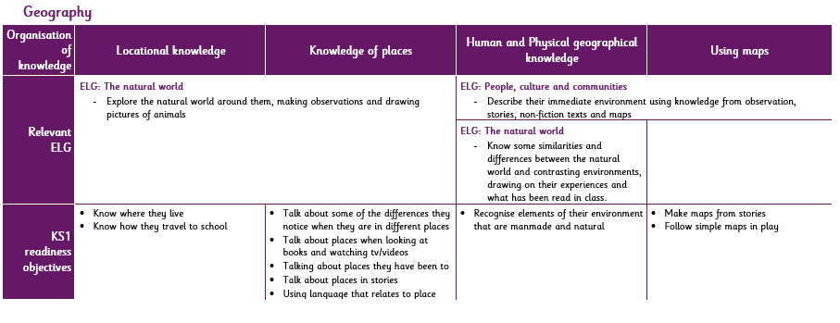
Early Learning Goal  Understanding the World: People, Culture and Communities  - Describe their immediate environment using knowledge from observation, discussion, stories, non-fiction texts and maps.  - Explain some similarities and differences between life in this country and life in other countries, drawing on knowledge from stories, nonfiction texts and (when appropriate) maps.  Understanding the World: The Natural World  - Know some similarities and differences between the natural world around them and contrasting environments, drawing on their experiences and what has been read in class. | National Curriculum Year 1  Pupils should develop knowledge about the world, the United Kingdom and their locality. They should understand basic subject-specific vocabulary relating to human and physical geography and begin to use geographical skills, including first-hand observations, to enhance their locational awareness.  Locational Knowledge  - Name and locate the world’s seven continents and five oceans.  - Name, locate and identify characteristics of the four countries and capital cities of the United Kingdom and its surrounding seas.  Place Knowledge  - Understand geographical similarities and differences through studying the human and physical geography of a small area of the United Kingdom, and a small area in a contrasting non-European country.  Human and Physical Knowledge  - Identify seasonal and daily weather patterns in the United Kingdom and the location of hot and cold areas of the world in relation to the equator and the North and South Poles.  Use basic geographical vocabulary to refer to:  - Key physical features, including beach, cliff, coast, forest, hill, mountain, sea, ocean, river, soil, valley, vegetation, season and weather.  Use basic geographical vocabulary to refer to:  - Key human features, including city, town, village, factory, farm, house, office, port, harbour and shop.  Geographical Skills and Fieldwork  - Use world maps, atlases and globes to identify the United Kingdom and its countries, as well as the countries, continents and oceans studies at this key sage.  - Use simple compass directions (North, South, East, West) and locational and directional language [for example, near and far; left and right], to describe the location of features and routes on a map.  - Use aerial photographs and plan perspectives to recognise landmarks and basic human and physical features; devise a simple map; and use and construct basic symbols in a key.  - Use simple fieldwork and observational skills to study the geography of their school and its grounds and the key human and physical features of its surrounding environment.

