.Understanding the World | Development Matters | Skills | How is this achieved in EYFS | By the end of EYFS the children will be…..
.Understanding the World | Reception:  - Learn new vocabulary  - Ask questions to find out more and to check wat has been said to them  - Articulate their ideas and thoughts in well-formed sentences.  - Describe events in some detail.  - Use talk to work out problems and organise thinking and activities. Explain how things work and why they might happen  - Use new vocabulary in different contexts  - Know and talk about different factors that support overall health and wellbeing such as: regular physical activity, healthy eating, toothbrushing, sensible amounts of screen time, having a good sleep routine  - Being a safe pedestrian.  - Explore the natural world around them  - Describe what they see, hear and feel whilst outside.  - Recognise some environments that are different to the one in which they live.  - Understand the effect of changing seasons on the natural world around them. | Autumn 1:  Use names of body parts  Describe what they see, hear and feel when they are outside.  Become familiar with immediate surroundings (school) and talk about its features.  - I know some body parts and can say what they do.  Autumn 2:  Begin to understand the effect of changing seasons on the natural world around them. (Autumn)  Describe what they see, hear and feel whilst outside.  - I know the main changes that happen in Autumn, Winter, Spring and Summer.  Spring 1  Explore and care for natural world around them - (birds in winter).  Begin to understand the effect of changing seasons on the natural world around them (winter) and make comparisons to previously experienced seasons.  Explore changing states of matter - freezing and melting.  Make observations about animals and environments, discuss  - I know that ice melts when it gets hot.  - I know that water turns into ice when it freezes.  - I know that some animals sleep during the winter.  - I know that the weather is different in different parts of the world.  Spring 2  Describe what they see, hear and feel whilst outside.  Explore and ask questions about the world around them.  - I know some foods that are healthy and not healthy.  - I know why we need to wash our hands and brush our teeth.  Summer 1  Make observations about animals and plants discussing similarities and differences.  Understand processes and changes in the natural world, including the seasons and life cycles, and make comparisons to previously taught (human life cycle).  - I know that a plant needs light, soil and water to grow.  - I know that plants die if they don’t have enough water.  - I know that a tadpole becomes a frog and a caterpillar becomes a butterfly.  Summer 2:  Draw pictures and make observations about animals and plants discussing similarities and differences (focusing on sea creatures in comparison to land creatures). | Autumn 1:  All about me  - Naming body parts through songs: if you’re happy and you know it and head, shoulders, knees and toes, observational drawing and Fred games.  - Explore our school grounds and school building.  - Explore how we look after our classroom. Keeping it clean, putting rubbish and recycling in the bin  - Use senses to explore and describe vegetables  - Discussions around snack time and lunch time - healthy eating choices.  Texts  My Body- Usbourne  The Enormous Turnip  Pumkin Soup- Helen Cooper  Autumn 2:  Sparkly Celebrations  - Plant spring and summer bulbs ready for next year  - Exploring school’s grounds and observing seasonal changes in the Autumn  - Exploring natural autumnal materials outside and in a Tuff Tray, asking questions and making/drawing observations. Leaf Litter/Leaf Rainbow  - Autumn crowns  - Observe seasonal weather changes and longer nights in the autumn compared to the summer  - Spend time tidying our planting area outside. Assign ‘Green Fingers’ role each week for children to take responsibility for watering and caring for plants  Texts  Leaf Man- Lois Ehlert  Percy the Park Keeper, The Lost Acorns – Nick Butterworth  Spring 1:  My Nighttime World  - Observe changes – light/dark  - Build a raft for the Chinese Zodiac animals (floating and sinking exploration)  - Looking after wildlife in the Winter  - Observe changes in ice  - Explore hibernation and migration, looking at contrasting environments/animals around the world in the Winter.  Texts  Day Monkey, Night Monkey – Julia Donaldson  Owl Babies – Martin Waddel  Pease at LastJill Murphey  Spring 2  On Our Doorstep  - Spring walk around school grounds describing and discussing what is found.  - Observe, question and draw spring plants/spring growth.  - Explore natural spring resources in Tuff Tray, asking questions and making/drawing observations- blossom.  - Materials – what is the best material for the Three Pigs to build a house out of? Investigate the property of materials.  - Healthy me - healthy eating choices.  - Discussions around healthy living choices including: washing hands, brushing teeth, eating and exercise  Texts  Three Little Pigs  The Queen’s Hat- Steve Antony  Daisy Eat your Peas- Nick Sharratt  Not Everyone is Nice- Let’s talk book by Anna Tedesco  I don’t Want to Wash my Hands – Tony Ross  Green Eggs and Ham – Dr Seuss  Oliver’s Vegetables- Alison Bartlett and Vivian French  Summer 1:  Down at the Bottom of the Garden  - Planting seeds and plants  - Explore the life cycle of plants  - Still life observations and drawings of flowers.  - Explore the life cycle of a Caterpillar.  - Exploring schools’ grounds and observing seasonal changes in the summer.  - Making suncatchers  - Exploring gardens and who lives in there?  - Mini-beast – Explore, observe and identify UK minibeasts.  - Look after our local environment – build minibeast houses  Texts  The Tiny Seed  Watch me Grow Frog – DK Books  The Very Hungry Caterpillar – Eric Carl  Oliver’s Vegetables – Vivan French  Summer 2:  We are Seaside Story Tellers  - Drawing around our friends and labelling body parts  - Observe, explore and compare contrasting natural environments around the world: Jungle, forest, great barrier reef  - Learn about sea creatures – find out facts and make fact books  - Learn about David Attenborough and the work he has done during his lifetime.  - Create pulleys- discuss forces  - Tally charts – things I have enjoyed most in Foundation, linked to PSHE.  Text  The Lighthouse Keepers Lunch – Davis Armitage  Tiddler – Julia Donaldson  Snail and the Whale – Julia Donaldson | Exceptional explorers who can talk about the world around them and changes in nature.
Vocabulary:
- Healthy, unhealthy, germs, head, legs, arms, hands, feet, shoulders, face, eyes, ears, mouth, tongue, teeth heart, brain, bones, skin.
- Autumn, winter, spring, summer, weather, hot, cold, snowing, freezing, warm, wet, cloudy, harvest, farming, leaves, light, dark, arctic, polar.
- Plants, grow, soil, sunlight, fruit, vegetable, tree, flower, water.
- Life cycle, grow, change, tadpole, froglet, frog, larva, caterpillar, chrysalis.
- Material, float, sink, plastic, fabric, wood, strong, waterproof, bendy, light,
- Pollution, recycle, rubbish, environment, community.
- Minibeast, ant, spider, worm, snail, habitat.
- Leaf, tree, pine, ash, birch, willow, Horse Chestnut
- Octopus, starfish, crab, camouflage

The Natural World
- Explore the natural world around them, making observations and drawing pictures of animals and plants.
- Know some similarities and differences between the natural world around them and contrasting environments, drawing on their experiences and what has been read in class.
- Understand some important processes and changes in the natural world around them, including the seasons and changing states of matter.

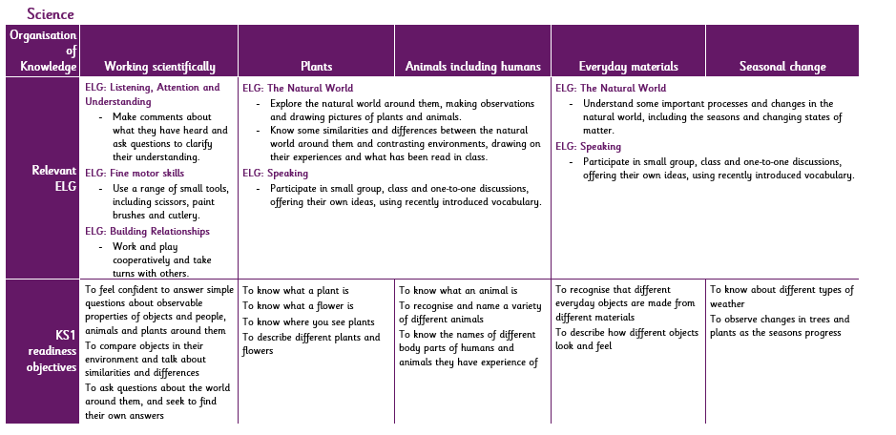
Early Learning Goal  Understanding the World: The Natural World  - Explore the natural world around them, making observations and drawing pictures of animals and plants.  - Know some similarities and differences between the natural world around them and contrasting environments, drawing on their experiences and what has been read in class.  - Understand some important processes and changes in the natural world around them, including the seasons and changing states of matter. | National Curriculum Year 1  Working Scientifically  During year 1 and 2, pupils should be taught to use the following practical scientific methods, processes and skills through the teaching of the programme of study content.  - Asking simple questions and recognising that they can be answered in different ways.  - Observing closely, using simple equipment.  - Performing simple tests.  - Identifying and classifying.  - Using their observations and ideas to suggest answers to questions.  - Gathering and recording data to help in answering questions.  Plants  - Identify and name a variety of common wild and garden plants, including deciduous and evergreen trees.  - Identify and describe the basic structure of a variety of common flowering plants, including trees.  Animals, Including Humans  - Identify and name a variety of common animals, including fish, amphibians, reptiles, birds and mammals.  - Identify and name a variety of common animals that are carnivores, herbivores and omnivores.  - Describe and compare the structure of common animals (fish, amphibians, reptiles, birds and mammals, including pets.)  - Identify, name, draw and label the basic parts of the human body and say which part of the body is associated with each sense.  Everyday Materials  - Distinguish between an object and the material from which it is made.  - Identify and name a variety of everyday materials, including wood, plastic, glass, metal, water and rock.  - Describe the simple physical properties of a variety of everyday materials.  - Compare and group together a variety of everyday materials on the basis of their simple physical properties.  Seasonal Change  - Observe changes across the four seasons.  - Observe and describe weather associated with the seasons and how day length varies.

