HOLIDAY CLUB BOOKING FORM
EASTER 2025

Acorn Childcare Centre is pleased to be running its Easter Holiday Club between 7 April 2025 and 22 April 2025.
Any primary-aged child is welcome to attend our holiday club, even if they do not attend Malcolm Sargent Primary School, provided they are registered with Acorn before attending. Please see the registration and booking form below.
The below timetable is in addition to all our usual activities including pool table, table tennis, air hockey, Lego, small world play, arts and crafts, and football, cricket, basketball, giant games, and lots more!
All outside activities are subject to change depending on weather conditions.

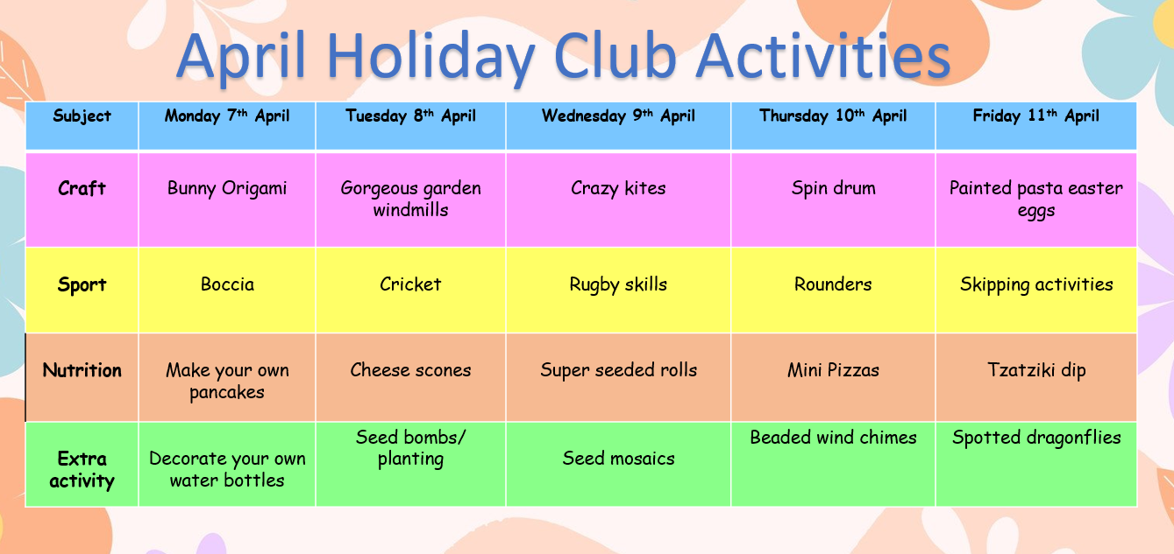

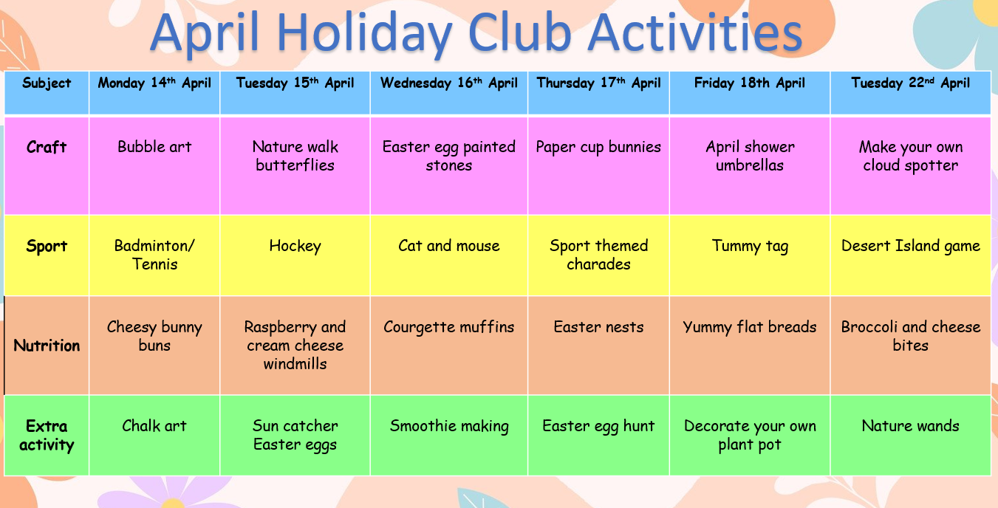

Please tick the day and session you require and return to enquiries@acornchildcarecentre.co.uk or drop into the Acorn reception.

Child/Children’s name:
Parent name:
Child/Children’s year group:

Day | Session 9am-3pm | Session 7:30am -6pm
Monday 7th April
Tuesday 8th April
Wednesday 9th April
Thursday 10th April
Friday 11th April

Monday 14th April

Tuesday 15th April

Wednesday 16th April

Thursday 17th April

Friday 18th April

Tuesday 22nd April

Please see below the terms and conditions of booking:
- Bookings are to be made by using the form below. Please tick the day and session required and return via email to enquiries@acornchildcarecentre.co.uk
- The two session times will be 0900 to 1500, or 0730 to 1800. You will be able to drop and collect children at any time during the longer day session, but you will be charged for the full day.
- 48 hours’ notice is required when cancelling sessions (weekends are not included in the 48 hours).
- All meals/snacks are provided except for lunch. Please send your child in with a healthy packed lunch each day. Drinking water will be freely available at all times of the day and therefore no other drinks will be needed.
- All children must hold a current admission form with us and a deposit before attending. Admission forms can be requested at the Acorn office or via email.
- The 0900-1500 session will be run to this exact start and end time. If you require extra time around this session, please book the longer day to accommodate your childcare needs.
- Sessions will be charged as follows: 0900-1500 = £30.80 and 0730-1800 = £48.40.

