

Love To Learn

ALLERGENS & ANAPHYLAXIS POLICY
APPROVED DATE: SEPTEMBER 2025
REVIEW DATE: SEPTEMBER 2030

Malcolm Sargent Primary Schol
Empingham Road
Stamford PE9 2SR
01780 756056
www.malcolmsargentschool.co.uk

Statement of Intent
This school is committed to promoting a whole school approach to health care, welfare and wellbeing and the safe management of those members of our school community who live with specific allergies. We believe that allergies should be taken seriously and dealt with in a professional and appropriate way. By our actions, we will work proactively to:
- Minimise the risk of exposure within the school setting.
- Encourage self-responsibility.
- Learn avoidance strategies.
- Have robust plans for an effective response to possible emergencies.
- Ensure inclusivity for all pupils.
Equalities Statement
Our school is clear about the need to actively support pupils with medical conditions to participate in school life.
The school will consider what reasonable adjustments need to be made to enable these pupils to participate fully and safely in all aspects of school life.
Risk assessments will be carried out so that planning arrangements take account of any steps needed to ensure that pupils with medical conditions are included. In doing so, pupils, their parents and any healthcare professionals will be consulted.
Context
Food allergies are increasing in both developed and developing countries especially in children and the severity and complexity of food allergy is also increasing. Food allergy can be fatal, and an appropriate diagnosis is essential in parallel with the need for clear food labelling worldwide.
Around 5-8% of children in the UK live with a food allergy and most school classrooms will have at least one allergic pupil. These young people are at risk of anaphylaxis, a potentially life-threatening reaction which requires an immediate emergency response. 20% of severe allergic reactions to food happen whilst a child is at school, and these reactions can occur in children with no prior history of food allergy. It is essential that staff recognise the signs of an allergic reaction, symptoms and can manage it safely and effectively.
Schools have a legal duty to support pupils with medical conditions, including allergy.
Principles
- To comply with all relevant environmental legislation, regulations and requirements.
- To encourage proactive steps to keep pupils safe.
- To ensure pupils from diverse backgrounds, ethnicities or different cultural heritages are not disadvantaged when dealing with allergies and food labelling.
- To work with the catering provider and its team to establish a robust and process and documentation for menu planning, food labelling, storing, avoidance of cross-contamination, stock ordering of food and drink used at the school.
- To provide an effective staff awareness programme on food allergies and intolerances, possible symptoms (anaphylaxis) recognition and actions to take.
- To develop a pupil awareness programme through PSHE and other curriculum areas.
Allergy Management Checklist
- Does the child have an Individual Health Care (IHC) Plan?
- Has the school purchased spare Auto-Adrenaline Injectors (AAIs)?
- Does each child have a completed and signed British Society for Allergies & Clinical Immunology (BSACI) Allergy Action Plan?
- Have all school staff been trained in allergy and anaphylaxis?
- Does the school have a policy or written instruction on where and how to store AAIs?
- Is there a schedule to check the expiry dates on spare AAIs and each child’s AAI?
- Does the school have a policy or written instructions to cover catering for children with allergies?
- Does the school include pupil allergy awareness in its curriculum?
- Does the school have a written allergy risk assessment?
- Does the school have a written risk assessment for extra-curricular activities?
The school has checked these bullet points and is able to respond positively to all of them.
Practical Steps (see also Appendices 1 and 3)
To put these principles into practise, Trustees will:
- Ensure the school has a strategic vision for the management of allergy risk assessment and emergency procedures.
- Delegate the day-to-day responsibility for the effective delivery of this policy to the Principal.
- Ensure the school’s arrangements to identify and safeguard the wellbeing of pupils because of their own or someone else's allergy are effective and robust.
- Ensure the school provides appropriate training, information, instruction, induction and supervision on a regular basis to enable everyone to stay safe regarding allergies and their management. It is good practise to log all training and attendees.
- Ensure adequate resources are available for managing allergies.
- Ensure appropriate material is available on the school website for parents/carers highlighting how the school is managing pupils with allergies.
- Monitor the effectiveness of this policy to ensure it remains fit for purpose. The next review of this policy is scheduled for September 2030.
The Principal will:
- Provide, as far as practicable, a safe and healthy environment in which people at risk of allergic reaction and anaphylaxis can participate equally in all aspects of school life and are not subject to bullying because of their condition.
- Ensure all staff, volunteers, student teachers and work experience students are made aware of the school’s commitment to allergy management.
- Ensure that visitors and sub-contractors are made aware that the school is an allergy-aware school and information regarding allergies and appropriate action in the event of an allergic reaction is shared with them.
- Ensure the curriculum contains age-appropriate content so that all pupils can learn about allergies and how everyone can support those who have them.
- Create links at strategic level with healthcare professionals and catering providers and ensure at operational level that these are robust.
- Ensure that up to date allergy information for pupils is accessible to catering providers.
- Ensure there is a workable School Emergency Plan in place that is known to all staff.
- Ensure the school sends a copy of the medical details it holds for the child to parents for review and update at the end of each school year.
- Ensure the school will seek updated medical information at the commencement of each academic year and for any pupil joining in-year.
- If a pupil has an IHC Plan, the school will ensure the involvement of healthcare and welfare professionals, teaching and catering staff, parents and the pupil in establishing the plan.
- Request parents to provide an allergy action plan, which must be completed and signed by a healthcare professional. This plan will be kept with the allergic child’s medication, with copies made available for all relevant staff to access and help support the pupil.
- Ensure effective communication of individual pupil medical needs to all relevant staff and ensure they know how and where to check for updated information.
- Ensure there are sufficient staff trained in first aid to meet the statutory requirements and assessed needs allowing for staff absences away from the school premises.
- Ensure first aid training includes anaphylaxis management including awareness of triggers, anaphylaxis and first aid emergency procedures.
- Ensure an adequate risk assessment is undertaken prior to any school trips, excursions or off-site activities for pupils who have allergies.
- Ensure records of pupils medically prescribed an AAI and its use are kept correctly.
- Ensure student documentation and in date medication is kept correctly and safely.
- Ensure best practise in the labelling of foodstuffs and their contents.
- Report to the Board of Trustees regarding the management of allergies within school.
- Follow all legal requirements recommended for best practise and whole school procedures relating to allergies within school context.
Members of the Senior Leadership Team (SLT) will:
- Support the Principal with the operational delivery of his responsibilities under this policy.
- Report to the Principal regarding children with allergies.
- Lead on the training of staff regarding allergy medical needs and their identification and management.
- Monitor items used on site to ensure that they are appropriate and suitable for children with allergies.
- Monitor and support class teachers with their responsibilities under this policy.
Class teachers will:
- Meet parents at least once each year, preferably at the start of the academic year, to ensure that the latest allergy action plan is with the school.
- Ensure that all allergy action plans are shared with the School Administrator on receipt.
- Work closely with the catering team in assisting in the support of pupils with allergies, including meeting parents when requested, to discuss any special arrangements.
- Liaise with parents regarding home-baked or other items are brought into school ie for fund-raising initiatives, birthdays for class children etc and dissuade parents from bringing these into school
- Whenever possible use an allergy action plan for pupils with recognised allergies and keep it with their medication, ensuring copies are available for all staff to access.
- If an additional IHC Plan is not required, ensure that the allergy action plan is viewed and treated with the same seriousness.
- Ensure copies of the IHC Plan and allergy action plan are located round school and/or on IT systems and are identical if an updated version is received.
- If an allergy action plan has not been received for a pupil with recognised allergies, or if the medication information is not clear, liaise with the pupil’ GP or paediatric allergy nursing team to obtain an up-to-date copy and/or clarification.
- Ensure medication is stored in a rigid box clearly labelled with the pupil’s name and photograph if the children in their class are not carrying their AAIs and medication with them.
- Be trained in the use of AAIs and be competent in performing any possible required prescribed medical treatment as outlines in the pupil’s IHC Plan and/or allergy action plan.
- Ensure that any other staff involved with those pupils requiring the use of an AAI are also adequately trained and competent.
- Ensure all school trips, excursions and off-site visits are pre-checked so that ‘safe’ food is provided or that an effective control is in place to minimise the risk of exposure for pupils with allergies.
- Before working with any food/drinks as part of the curriculum, or sharing any food in class, or preparing for any food tasting events, to check the parental consent on the school’s MIS each time and if in any doubt, contact the child’s parent for direct permission for each and every event.
Emergency First Aiders at Work will:
- Ensure that the school has an audited spare supply of in date AAIs which are kept in a safe space at room temperature which are accessible, secure and not locked away and that all staff are aware of their location.
- Monitor the use of AAIs to ensure that they are within their expiry date including those bought into the school by the pupils and those bought by the school from external sources and are of the correct dosage.
- Arrange for the correct disposal of out-of-date AAIs.
The School Administrator will:
- Ensure that all Allergy Action Plans are scanned on receipt, uploaded to the Z drive for access by the relevant staff and shared with the class teacher for printing and adding to the child’s emergency allergy medication, with the original being filed on the pupil file.
- Ensure that all allergy medical information and medications are updated on the pupil’s MIS record.
- Ensure that the Critical Illness List is updated in a timely manner and shared with the relevant staff in school including the catering team.
All staff will:
- If anaphylaxis is suspected in an undiagnosed pupil, call the emergency services and state “anaphylaxis” is suspected, then follow their advice as to whether the administration of a spare AAI is appropriate.
- Record all emergency uses of AAIs or reports of suspected emergencies.
- Ensure that if a pupil notifies the school that they are no longer allergic to a food, this information is check prior to updating records and the IHC Plan.
- Follow as directed all the requirements of the school including all legal requirements, recommended best practise, and whole school procedures pertaining to allergies within the school context.
- Complete appropriate anaphylaxis training and be confident in responding to an allergy emergency.
- Raise awareness about allergies and anaphylaxis amongst their pupil in the classroom and around school, especially in dining areas.
- Encourage self-responsibility and learned avoidance strategies amongst pupils living with allergies.
- Help all pupils understand which foods are safe for those with allergies and how they can support other pupils with specific dietary needs to stay safe.
- Highlight the need for anti-bullying of pupils with allergies.
- Be aware of the pupils in their care (including in regularly covered classes) who have known allergies as an allergic reaction could occur at any time and not just at breaks or mealtimes.
- Any food-related activities ie cookery lessons or food tasting must be supervised with due caution following best practise for storing, preparing, cooking or serving food.
- Any staff leading on a school trip must check that all pupils with medication conditions, including allergies, are carrying their medication and those unable to produce their medication would not be able to attend the trip.
- Staff leading school trips or excursions must ensure that they carry all relevant emergency supplies with them and be clear on the agreed emergency procedures for the children in their care, referring to their allergy action and/or asthma plans and/or Individual Health Care Plans as appropriate.
Parent(s) will:
- Notify the school of their child’s allergies.
- Inform the school of any changes as soon as they are known.
- Talk with their child about allergy self-management including what foods are safe and unsafe, how to read food labels, strategies for avoiding allergens, how to spot the symptoms of an allergy, and how and when to tell an adult if experiencing an allergic reaction.
- Provide an allergy action plan completed by a healthcare professional which can be kept with their child’s medication.
- Help the school to support their child.
- Contribute to the provision of an IHC Plan in partnership with the school and relevant healthcare professionals as required.
- Provide any other written medical documentation, instructions and medication as directed by a health professional.
- If required, meet with the catering team to discuss any specific requirements relating to your child’s allergy. Information from these meetings will be recorded by catering team.
- Be aware of the content of this policy and any arrangements for managing children with allergies and at risk of anaphylaxis.
- Communicate regularly with the school to support its ability to keep your child safe and act immediately in the event of an allergic reaction.
- Provide appropriate in-date medication (two AAIs) of the correct dosage and register their AAIs on the manufacturer’s website to receive text alerts for expiry dates.
- Provide appropriate foods to be consumed by your child if necessary.
- Replace medications quickly after use or on expiry.
- Review this policy and the school’s procedures with the school’s Principal or other designated member of staff, the pupil’s GP or other medical professional and with your child (if appropriate) after an allergic reaction has occurred.
- Ensure that their child’s anaphylaxis kit is up-to-date and clearly labelled.
- Send in packed lunches (unless they have a hot lunch), snacks, water bottles, milk in cartons, or other drinks for their child, clearly labelled.
Pupils with allergies (if appropriate) will:
- Have a good awareness of their allergy and support the knowledge of their peers in helping keep themselves safe.
- Be proactive in the care and management of their food allergies, reactions and medications.
- Not exchange foods with others and take care to avoid foods which may cause an allergic reaction.
- Read food labelling and if unsure, avoid the food.
- Avoid eating anything with unknown ingredients.
- Know where their medication is kept and (if confident enough to administer their own AAIs) take responsibility for carrying their emergency medication, including AAIs, on their person at all times.
- Tell an adult as soon as they suspect they are experiencing an allergic reaction.
Supply, Storage and Care of Medication
Depending on their level of understanding and competence, pupils will be encouraged to take responsibility for and to always carry their own two AAIs and other emergency medication with them in a suitable bag. Younger children or those not ready to take responsibility for their own medication, there should be an anaphylaxis kit available and accessible to all staff, which is secure but not locked.
Medication should be stored in a suitable bag and clearly labelled with the pupil’s name. The bag should contain:
- Two AAIs (Jext, Epi-Pen or Emerade).
- An up-to-date allergy action plan.
- Antihistamine as tablets or syrup (with a spoon) if included on the allergy action plan.
- Asthma inhaler (and spacer if required) if included on the allergy action plan.
It is the responsibility of the pupil’s parent(s) to ensure that their child’s anaphylaxis kit is up to date and clearly labelled. However, a designated member of the school staff will check medication kept at school monthly and send a reminder to parents if medication is approaching its expiry date. Parents can subscribe to expiry alerts from the manufacturers of the AAIs which their child carries to make sure they can obtain replacement devices in good time.

Older Children & Medication
Older children and teenagers should, whenever possible, assume responsibility for their emergency kit under the guidance of their parents. However, symptoms of anaphylaxis can come on very suddenly so school staff need to be prepared to administer medication if the young person cannot.
Storage
AAIs should be stored at room temperature, protected from direct sunlight and temperature extremes.
Disposal
AAIs are single use and must be disposed of as sharps. Used AAIs can be given to ambulance paramedics on arrival or can be disposed of in a pre-ordered sharps bin. Sharps bins are to be obtained from and disposed of by a specialist clinical waste contractor.
The school’s sharps bin is kept in the school office.
Spare AAIs
School can now legally purchase and store spare AAIs for use with children at risk of anaphylaxis. Immediate access to AAIs can be lifesaving. Whilst it is vital that families have their own prescribed AAIs for their child, having spare AAIs at school adds an extra layer of reassurance for everyone involved. It is a step towards creating a safer and more inclusive environment for children managing severe allergies.
Catering
All food businesses, including school caterers, must follow the Food Information Regulations 2014 which state that allergen information relating to the top fourteen allergens must be available for food products.
The school menu has six-month rotation, changing every October and April and repeats every three weeks. It is available to view with all ingredients and allergens listed via the SchoolGrid website at https://schoolgrid.co.uk/ .
The School Administrator will inform the catering team of pupils with food allergies. The catering team has photos of children with food allergies discreetly on view to them and the SchoolGrid system prevents parents/staff/pupils from ordering any food choices inappropriate for individual children.
The school and the catering team adhere to food allergy guidelines from the Department for Health, the Food Standards Agency and the School Food Standards as follows:
- Packed lunches, snacks, water bottles, cartoned milk or other drinks provided by parents for pupils with food allergies should be clearly labelled with the name of the child for whom they are intended.
- If food is purchased from the servery or elsewhere on site ie from the PTFA after school on the playgrounds, parents should check the appropriateness of foods by speaking to the catering team or PTFA representative.
- Pupils should be taught to ask the server/seller of foods about their appropriateness before buying or consuming them.
- Where food is provided by the school, staff should be educated about how to read food labels for allergens and instruction about measures to prevent cross contamination during the handling, preparation and serving of food. Examples include:

  - Preparing food for children with food allergies first.
  - Careful cleansing using hot soapy water of food preparation areas and utensils.

- For further information, parents are encouraged to liaise with the catering team.
- Food should not be given to pupils with food allergies without parental engagement and permission ie birthday parties, food treats.
- Use of foods in craft, cookery or science experiments or at special events ie fayres, assemblies, cultural events need to be considered and may need to be restricted and/or risk assessed depending on the allergies of the particular children and their age.
Allergy Awareness and Nut Bans
The school supports the approach advocated by many allergy charities towards nut bans/nut-free schools. They would not support a blanket ban on any particular allergen in any establishment including schools. This is because nuts are only one of many allergens which could affect pupils, and no school could guarantee a truly allergen free environment for a child living with a food allergy. They instead advocate for schools to adopt a culture of allergy awareness and education.
A whole school awareness of allergies is a much better approach as it ensures teachers, pupils and other staff are aware of what allergies are, the importance of avoiding the pupils’ allergens, the signs and symptoms, how to deal with allergic reactions and to ensure policies and procedures are in place to minimise risk.
Risk Assessment
The school will conduct a detailed individual risk assessment for all new and joining pupils with allergies, and for any pupils newly diagnosed, to help identify any gaps in its systems and processes for keeping allergic pupils safe.
The school also has a generic risk assessment relating to allergens and anaphylaxis which is shared with all staff and available for all staff to access as required and adapt this generic risk assessment as appropriate for individual children to meet their medical needs. This individual risk assessment will be stored on the pupil’s file at the office with a scanned copy being shared with the class teacher for their records, uploaded to the Z drive with the school’s MIS being appropriate updated.
Training
Allergy training should include a practical session using trainer AAIs which are available to order through the manufacturers’ websites. Training should include a basic understanding of allergic disease and its risks which include:
- Knowing the common signs and triggers of allergies.
- Spotting the signs and symptoms of an allergic reaction and anaphylaxis. Early recognition of symptoms is key, including knowing when to call for the emergency services.
- Administering emergency treatment including AAIs in the event of anaphylaxis, knowing how and when to administer the medication/device.
- Measures to reduce the risk of a child having an allergic reaction ie allergen avoidance.
- Knowing who is responsible and for what.
- Associated conditions ie asthma.
- Managing allergy action plans and ensuring these are up to date.
Allergies and Bullying
Our Behaviour Management & Exclusions Policy includes measures to prevent all forms of bullying amongst pupils. Allergy bullying is treated seriously, like any other bullying. We aim to ensure that all children with medication conditions, in terms of both physical and mental health, are properly supported in school so that they can play a full and active role in school life, remain healthy and achieve their academic potential.
The DfE has provided statutory guidance for schools and colleges on keeping children safe in education. Please see the guidance at the link below:
https://www.gov.uk/government/publications/keeping-children-safe-in-education--2
Other useful websites include:
The NSPCC
https://www.nspcc.org.uk/
National Bullying Helpline
https://www.nationalbullyinghelpline.co.uk/?scrlybrkr=17a10968
Family Lives
https://www.familylives.org.uk/?scrlybrkr=17a10968
Kidscape
https://www.kidscape.org.uk/
Anti-Bullying Alliance
https://anti-bullyingalliance.org.uk/
Young Minds
https://www.youngminds.org.uk/?gad_source=1&gad_campaignid=100441065&gbraid=0AAAAADk6C8fGqjL65-uE6-Uxyk3KugjXB&gclid=EAIaIQobChMIx7yRqtPfjwMVYZJQBh1P-jKZEAAYAiAAEgIksfD_BwE&scrlybrkr=17a10968
Childline https://www.childline.org.uk/?gclsrc=aw.ds&gad_source=1&gad_campaignid=20597026949&gbraid=0AAAAADp40Rix68Eix7VJyVhy9CALUyGam&gclid=EAIaIQobChMIqvH3utPfjwMVcZNQBh0dYS3rEAAYASAAEgLXlPD_BwE&scrlybrkr=17a10968
Bully Busters
https://localsolutions.org.uk/liverpool-city-region-services/support-accommodation/bullybusters/

Appendix 1 – First Aid for Anaphylaxis Poster

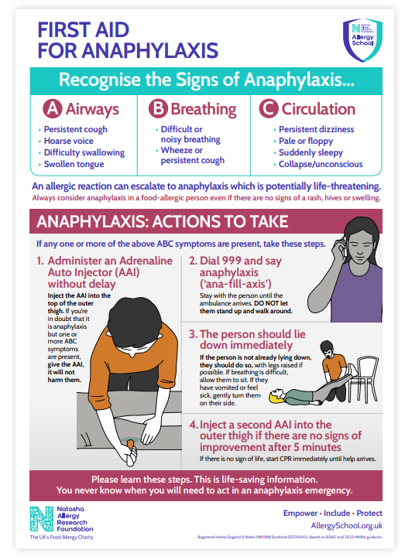

Appendix 2 – Epi-Pen Instructions

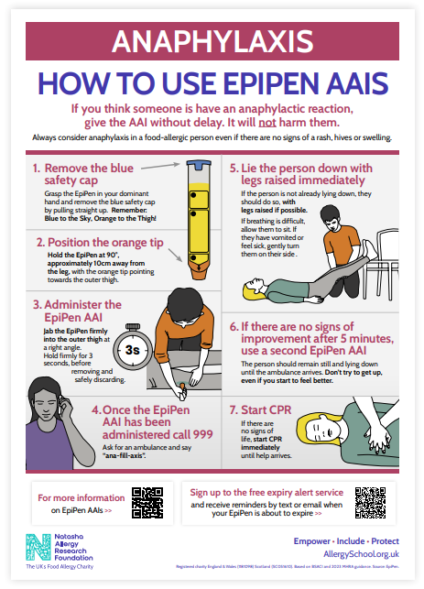

Appendix 3 – Jext Instructions

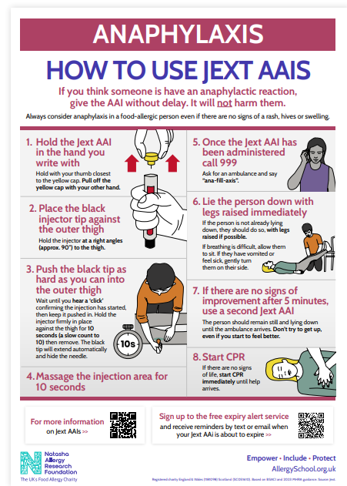

Appendix 4 – Flowchart for Allergic Reaction without use of an AAI

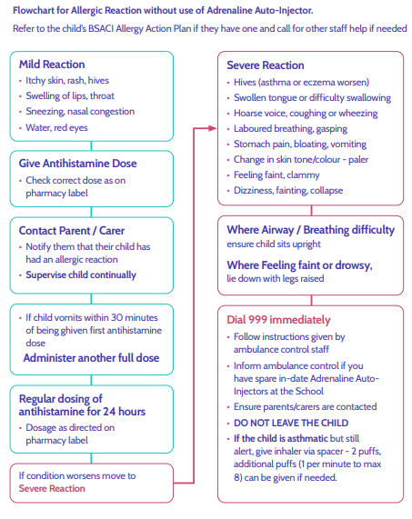

Appendix 5 - Flowchart for Allergic Reaction with use of AAI

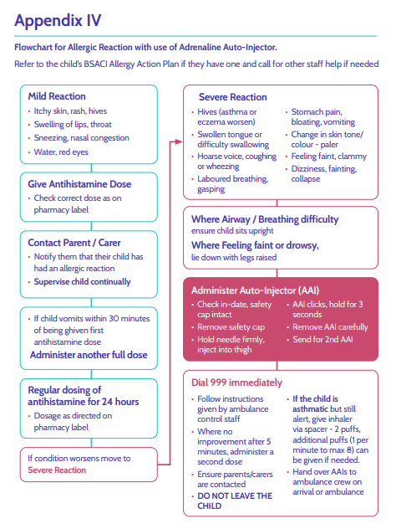

Appendix 6 – Information on Allergies

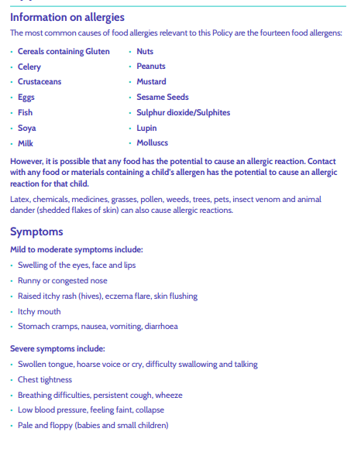

Appendix 7 – Other Support & Resources
Allergy Guidance for Schools - https://www.gov.uk/government/publications/school-foodstandards-resources-for-schools/allergy-guidance-for-schools
Allergy UK Helpline: providing support, advice and information for those living with allergic disease tel. weekdays 9am-5pm 01322 619898 – www.allergyuk.org
Early Years Foundation Stage Statutory Guidance, Section 3 Safeguarding and Welfare Requirements - Food and Drink - https://www.gov.uk/government/publications/early-years-foundation-stage-framework--2
Early Years Foundation Stage Nutrition - https://www.gov.uk/government/publications/early-years-foundation-stage-nutrition
Food Standards Agency food allergy and intolerance online training - https://allergytraining.food.gov.uk/
For pupils / students with Medical Conditions at School - Supporting pupils with medical conditions at school - https://www.gov.uk/government/publications/supporting-pupils-at-school-with-medical-conditions--3
Wales: https://www.gov.wales/sites/default/files/publications/2018-12/supporting-learnerswith-healthcare-needs.pdf
Scotland: https://www.gov.scot/publications/supporting-children-young-peoplehealthcare-needs-schools/
Northern Ireland: https://www.education-ni.gov.uk/publications/supporting-pupilsmedication-needs
FSA reporting tool for allergies - https://www.gov.uk/government/news/fsa-launchesallergy-and-intolerance-reporting-tool
Guidance on the use of adrenaline auto-injectors in schools (Department of Health, 2017) https://assets.publishing.service.gov.uk/government/uploads/system/uploads/attachment_ data/file/645476/Adrenaline_auto_injectors_in_schools.pdf
Wales: https://www.gov.wales/sites/default/files/publications/2018-12/guidance-on-theuse-of-emergency-adrenaline-auto-injectors-in-schools-in-wales.pdf
Training for Schools - https://www.anaphylaxis.org.uk/information-training/allergywisetraining/for-schools/
Transitioning to Secondary School - https://www.anaphylaxis.org.uk/living-with-seriousallergies/serious-allergy-guidance-for-parents/preparing-for-and-managing-thetransition-to-secondary-school/
Whole school allergy and awareness management - https://www.allergyuk.org/for-industry-and-education/schools-early-years/whole-school-allergy-awareness-management-2/?scrlybrkr=17a10968

Appendix 8 – Top 14 Allergens Poster
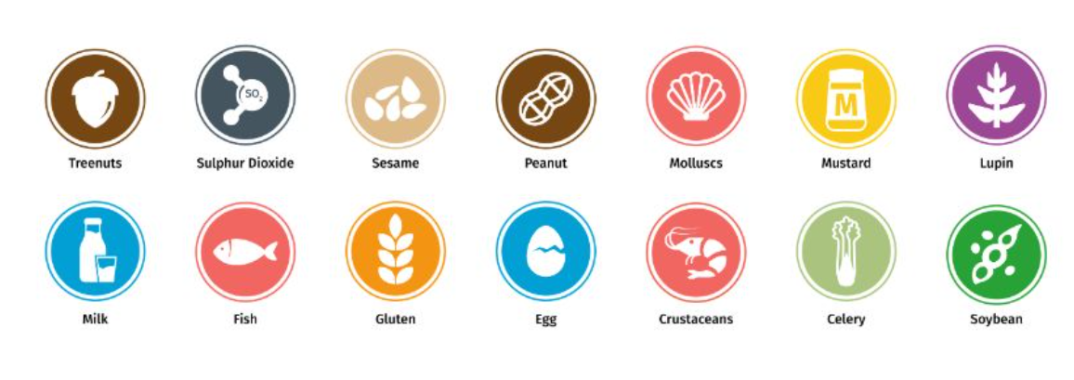

Appendix 9 – BSACI Allergy Action Plan Example



