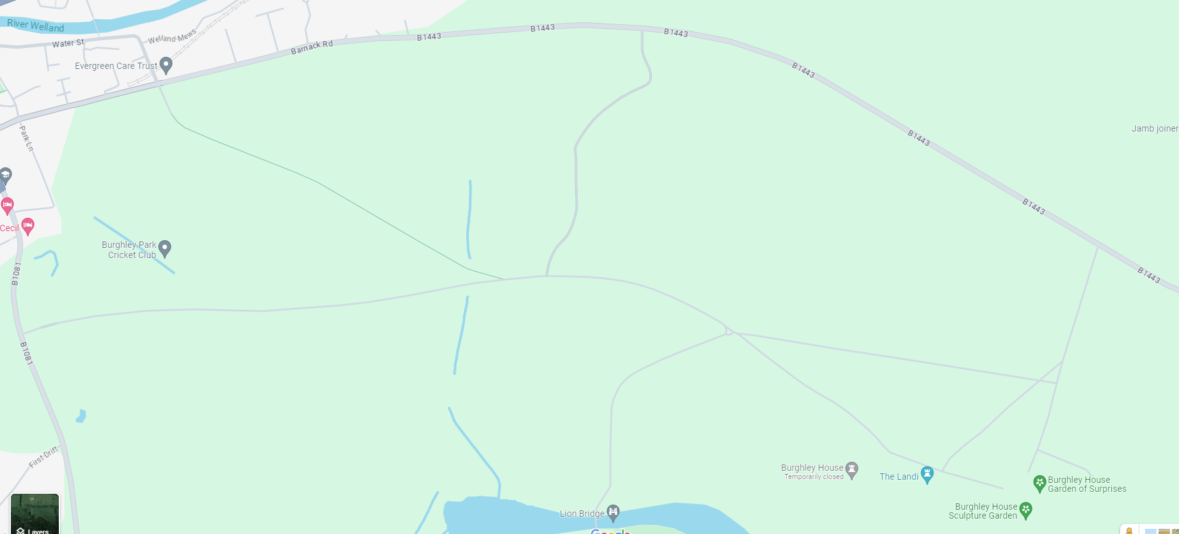
Stamford Primary Schools Cross Country Championships, 28th March 2026
Stamford Primary School Cross Country Event
No entry for cars or space to drop participants/spectators off.
Route from car park to event
Carpark
Car parking entrance

