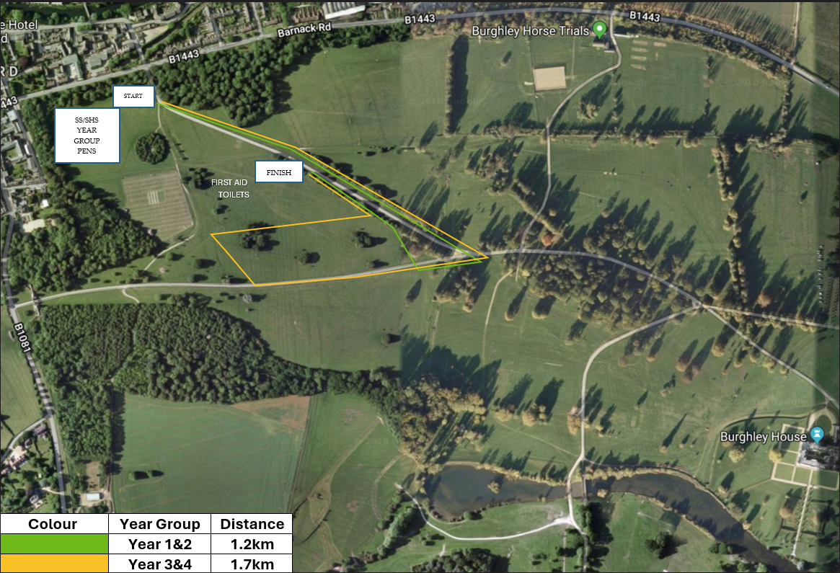
Stamford Primary Schools Cross Country Championships route, 28th April 2026
Year 5&6
Year 3&4

