EASTER HOLIDAY CLUB INFORMATION
Acorn Childcare Centre is pleased to be running its Easter Holiday Club on:
Tuesday 7th April - Friday 10th April
Monday 13th April – Friday 17th April
Monday 20th April
Any primary-aged child is welcome to attend our holiday club, even if they do not attend Malcolm Sargent Primary School, provided they are registered with Acorn before attending.
Please see the timetable of our activities on the next page. These timetabled activities are in addition to all our usual activities including pool table, table tennis, air hockey, Lego, small world play, arts and crafts, football, cricket, basketball, giant games, and lots more!
Please see below the terms and conditions of booking:
- Bookings are made via email to enquiries@acornchildcarecentre.co.uk or call on 01780 766493.
- The two session times are 09:00 to 15:00, or 07:30 to 18:00. You will be able to drop off and collect children at any time during the longer day session, but you will be charged for the full day.
In addition, we now offer two flexible add-on sessions: Early Bird Holiday Club (including breakfast) between 07:30 and 09:00 and Night Owl Holiday Club (including a light tea) between 15:00 and 18:00.
- Sessions will be charged as follows: 09:00-15:00 = £30.80 and 07:30-18:00 = £48.40. Add-on sessions: 07:30 to 09:00 = £7.70 and 15:00 to 18:00 = £15.40.
- In addition, a 10% discount will apply if 5 consecutive days are booked during the Easter holiday. This discount will apply to all days booked in the block.
- 48 hours’ working notice is required when cancelling sessions (weekends are not included in the 48 hours).
- All meals/snacks are provided except for lunch. Please send your child in with a healthy packed lunch each day. Drinking water will be freely available at all times of the day and therefore no other drinks will be needed.
- All children must hold a current admission form with us and a deposit before attending. Admission forms can be requested at the Acorn office or via email.
- All outside activities are subject to change depending on weather conditions.
Get ready for fun!
Have a look at the activities we’ve lined up; we can’t wait to enjoy them with you!
🐰🎀 🐣🌷 🐤

Easter Offer!!!
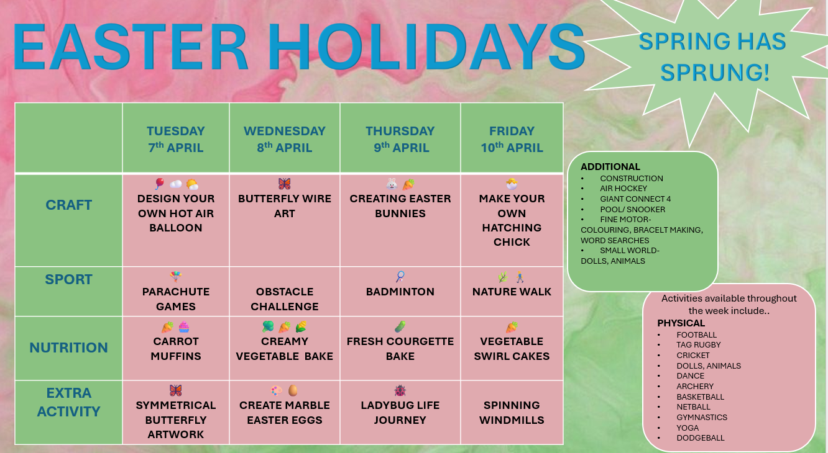
A 10% discount will apply if 5 consecutive days are booked during the Easter holiday. This discount will apply to all days booked in the block.


