13 October 2026

Dear Parents/Carers

Y6 DRAMA CLUB - INVITATION TO WATCH A SCREENING OF MATILDA
TUESDAY 20 OCTOBER 1515-1630

I am inviting the Y6 Drama Club to watch a screening of ‘Matilda’ so that all children have an opportunity to see the show and to have an idea of the plot, characters and songs. ‘Matilda’ is a PG film. I am asking for a donation of £2 to include the screening and some small snacks to enjoy whilst watching. This will help raise funds to buy materials for props, scenery and costumes for our show. The screening will take place during the usual drama club time.
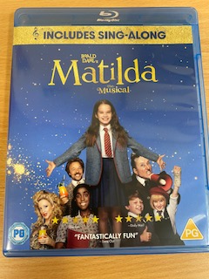
During the screening there will be 1 x ButterKist Sweet and Salty popcorn snack bag, 1 x Haribo Starmix mini bag and 1 x Walkers ready salted crisp bag for the children to enjoy whilst watching. I have attached photos, ingredients and allergy information for each of the items.

Please identify which food items your child will be allowed/not allowed to eat. If an item is not identified your child will not be given it to eat. Each child will be allowed one of the three different items of food only (ie they could have popcorn, Haribo or crisps).

Your child may bring in their own snacks if they wish to. If you are to do this, can I remind you that our school is a nut-free school and snacks should not contain any nut products. We take this very seriously as we have a number of children with food allergies including nut allergies. Children should bring their water bottle.

After the screening, a letter will shortly follow with the cast list, inviting the children to the auditions after half term.

If your child is attending the screening of Matilda, please fill out the form below carefully and return by FRIDAY 16 OCTOBER. Please include your donation £2 in an envelope with your child’s name and ‘Drama Club Donation’ and give to Mrs Mills or hand in at the office.

If the form is not completed and handed in we cannot give your child food.

Thank you for your understanding and hope that your child will enjoy watching ‘Matilda’.

Yours sincerely

Mrs Vicki Mills

Music Subject Leader and Drama Leader
Y6 DRAMA CLUB INVITATION TO THE SCREENING OF MATILDA - MRS MILLS

Child: _______________________________________________________ Class: ___________

- My child will attend the screening on 20 October
- My child will not attend the screening on 20 October
- My child has the following food allergies: ______________________________________
- My child will bring their own nut-free snacks
- My child can eat Butter Kist Sweet and Salty Popcorn snack bag provided by school (no specified allergens)

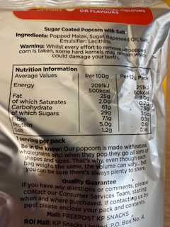
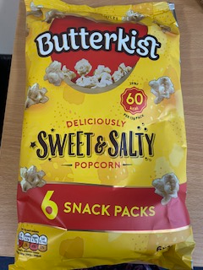

- My child can eat Walkers Ready Salted crisps provided by school (stated allergens are milk, soya, mustard, wheat and other cereals containing gluten)

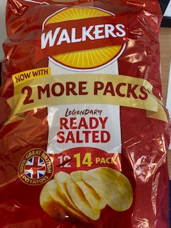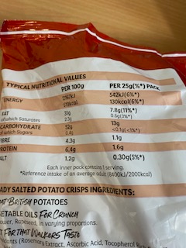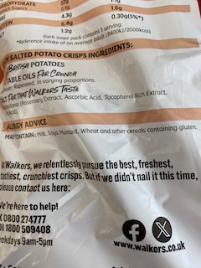

- My child can eat Haribo Starmix Minibag provided by school (no stated allergens but may be unsuitable for certain dietary requirements)
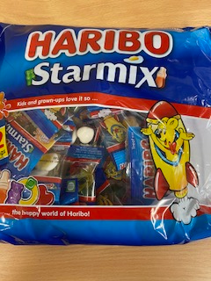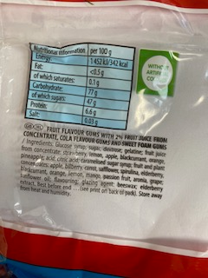

Signed: ______________________________________________________ (Parent/Guardian)

